Problem No: 03
Problem Name: Implement the Popular Image Enhancement Technique: Brightness Enhancement
Objective:
- To understand the concept of image brightness enhancement.
- To learn how pixel intensity affects image visibility.
- To implement brightness enhancement using Python.
- To improve the visual quality of a digital image.
- To gain practical experience in digital image processing techniques.
Theory: Brightness enhancement is an image processing technique used to increase or decrease the brightness of an image. It improves image visibility by modifying the intensity values of pixels.
In digital images, pixel values generally range from 0 to 255:
Brightness enhancement is performed by adding a constant value to each pixel intensity.
The mathematical expression is:
S=R+CS = R + CS=R+C
Where:
R = Original pixel value
C = Brightness constant
S = Enhanced pixel value
If the value exceeds 255, it is clipped to 255.
Code:
from PIL import Image
import matplotlib.pyplot as plt
import numpy as np

img = Image.open("sm_pic.jpg")
img_array = np.array(img)
brightness = 50
bright_img = np.clip(img_array + brightness, 0, 255)
bright_img = bright_img.astype(np.uint8)

plt.figure(figsize=(10,5))

plt.subplot(1,2,1)
plt.imshow(img)
plt.title("Original Image")
plt.subplot(1,2,2)
plt.imshow(bright_img)
plt.title("Brightness Enhanced Image")

print("Brightness Enhanced Image Matrix:\n")
print(bright_img)
plt.show()
Output:
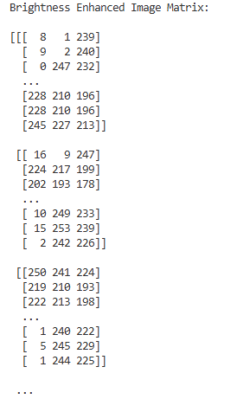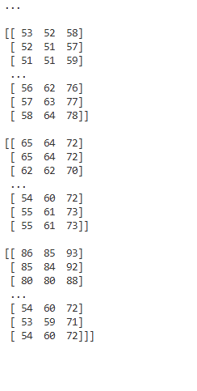
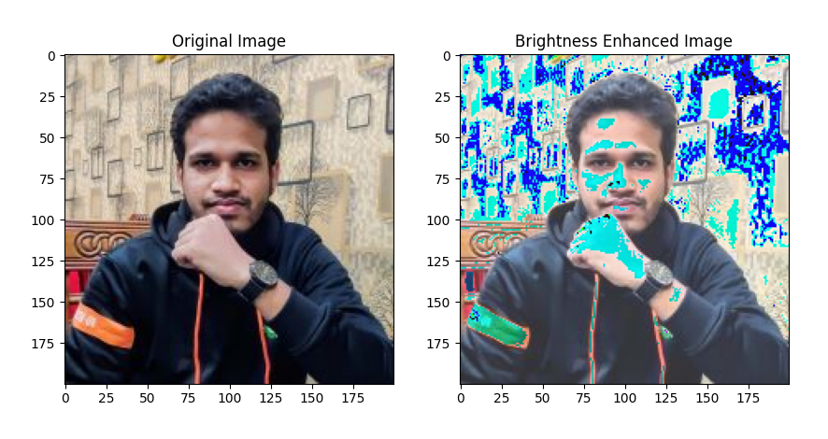
Result Discussion: The experiment successfully enhanced the brightness of the image by increasing pixel intensity values. The enhanced image appeared clearer and more visible compared to the original image. The brightness adjustment improved dark regions without changing the image structure.
The output matrix confirmed that pixel values were increased according to the brightness constant.
Analysis: Brightness enhancement is a simple but effective image enhancement technique. By adding a constant value to each pixel, image visibility can be improved significantly. However, excessive brightness may cause loss of image details due to overexposure.
This experiment demonstrated how intensity transformation can affect image appearance and quality.
Opinion: This experiment was very helpful for understanding basic image enhancement techniques. It provided practical experience with pixel manipulation and digital image processing using Python. Brightness enhancement is widely used in photography, medical imaging, and computer vision applications, making this experiment useful for real-world learning.

